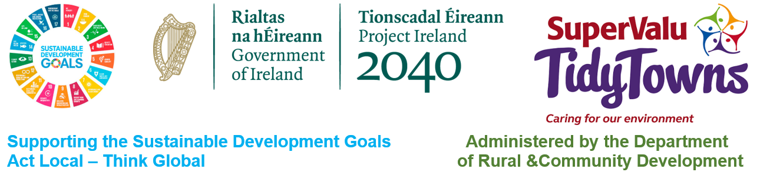

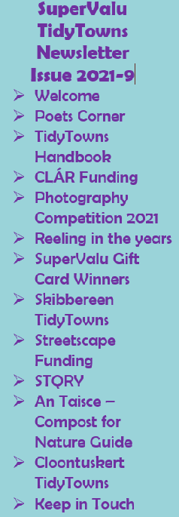

TidyTowns Family & Friends,

Welcome to the September edition of the SuperValu TidyTowns competition. As we head into autumn hopefully many of you can take a well-deserved break from your busy TidyTowns schedule but we hear from the Adjudicators of the tremendous efforts made by so many groups, so it appears some of you never stop striving to improve your place. Well done!

At this time of year, we would normally be looking forward to the Helix and the announcements of how you all did in the competition. Things will be different this year, we will still have the same awards as in previous years, indeed this year we have more, more special awards means more prizes. The awards will be announced in November, we are currently looking at the format of the ceremony at which the results will be made known and once all the details are finalised, we will share more information with you all. Rest assured medals, Certificates and Cash Prizes will all get to you as soon as possible, these may be posted to you this year as we may not have regional awards ceremonies given the time of year, hopefully in 2022, we will all be able to meet again and celebrate together as we have done so in the past.

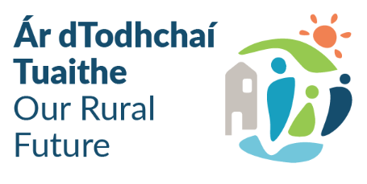We are delighted to announce more winners of SuperValu Gift Cards this month, four in fact with a total of €250 worth of Gift Cards on their way to groups. We are also opening the SuperValu TidyTowns Photography competition, this was a huge success last year so we are running it again with an increased prize fund of €700 so get those cameras out. Remember also to look through your files for old TidyTowns material, we would love to do a “Reeling in the Years” type piece in the winter to take you all down memory lane of TidyTowns as it was in years gone by.

We wish you all well in the coming months and wish you every success in the competition as we head towards the announcements. Look after each other, heed the health advice given and support your local community as business’s try to get back on their feet after a difficult period. If we all pull together, we’ll get there. We wish to advise from Monday September 24th our contact number will change to **01 - 7736938**. The “076” numbers will no longer be in use.

**Poets Corner**

This month, Marian Kelly from Ballynacally TidyTowns in Clare got in touch to share with us a poem she penned about her beautiful Village, Ballynacally.

***“Ballynacally My Home”***

Where is this little village

with its beauty oh so rare

where stone walls lead you up the road

amid blossoms sure none can compare

The old stone bridge stands prominent

and its arches five in all

the water flowing free beneath

only tides will make it stall

The echo from the bell tower

near the graceful church rings out

and the ruins of Dangan Castle

bring many a photographer about

The forge with its bellows and anvil

fond symbols of times past

and friendly folk stop up to chat

while at the shrine a prayer I clasp

Down at the pier I scan the islands

across the estuary clear

such majestic unspoiled beauty

as a boat soon does appear

Rose lovers, Paradise and Blessed Well

tranquil gems that must be seen

as children play near the old pump

at the centre of the fair green

Where is this enchanting village

oh I don’t have far to roam

its dear old Ballynacally

my community and my home

Thank you Marian for sharing those lines with us, such lovely imagery of stone walls and arch bridges, it all sounds so peaceful and inviting. Definitely one for us all to add to our places to visit the next time we head to Co Clare.

We are delighted to bring you another poem this month from one of our resident TidyTowns Poets, Denis Heffernan from Emly TidyTowns, here perhaps, Denis calls us all to notice those around us who are in need, not just to pass them by but to really see them and perhaps do what we can to help.

**The Man on the Bridge**

I see him now on the windy bridge his clothes all tattered and torn,

His ears are red his face is pale a drop falls from his nose,

With paper cup in his trembling hand he sits there all alone,

While some passers by give him the eye others don’t even notice.

Perhaps he was a carpenter who worked from nine to five,

Or he might have been a builder or worked on the railway line,

He might have been a footballer who for his parish played,

But now he is old and feeble and his life just fades away.

I wonder if he was married and had a wife and child,

Or has he brothers and sisters perhaps they have all died,

I wonder if he has a home with roses around the door,

With bacon on the ceiling and flagstones on the floor.

When I sit to eat my dinner with pork chops and apple sauce,

I think of this poor lonely man who has no dinner at all,

Suppertime means nothing or news on RTE,

Only shade from the wind and weather on the windy bridge sits he.

Tonight when I lay in slumber neat my patchwork quilt so warm,

I wonder where he will be resting neat the bridge in a sheltered corner,

No Pajamas he will be wearing only the same old ragged clothes,

That he wore on the windy bridge the same as the day before.

His head falls softly sideways the pain in his leg is no more,

He closes his eyes gently god is calling him home,

His life on earth is over,

The man on the bridge is no more.

Denis Heffernan

Summer 2021

The quality of these poems month after month is really amazing, we might look at putting them together later in the year and circulating them all to you to retain in one place. Such talent out there, poetry has a great way of not only telling a story but bringing you along for the journey so you see.

**TidyTowns Handbook – Updated**

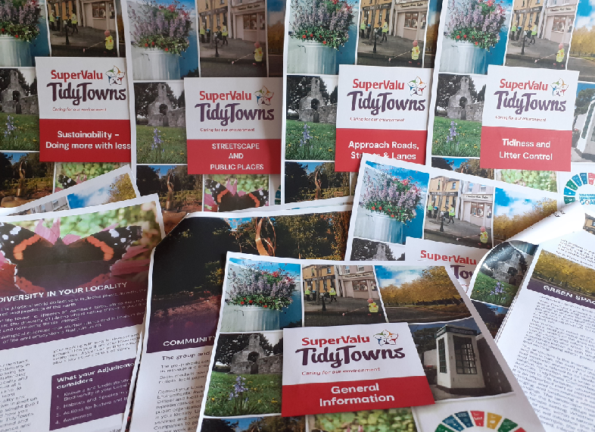The TidyTowns Handbook has been a valuable source of information on the competition for many groups for years. New groups refer to it to give them a steer in the first direction as they start off on their TidyTowns journey.

The Handbook was last updated in 2010 and as you are well aware a lot can change in ten years, categories have changed and best practice and advice changes all the time so we are now bringing you the most up to date advice available across all the adjudication categories.

With the competition not proceeding last year, the TidyTowns unit set about updating the handbook and took the decision to draft a new version entirely.

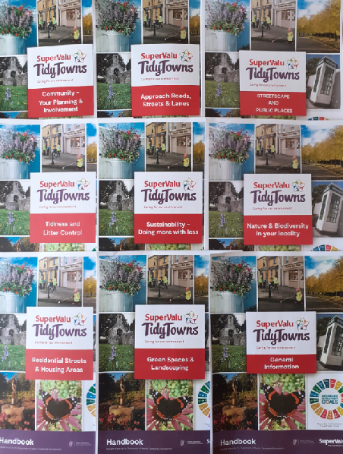The expertise and experience of the national panel of TidyTowns Adjudicators was called upon for their input and support and we thank them for their assistance.

We decided rather than developing one large Handbook, we went for themed sections. There are nine separate sections, a general information section which gives advice on all things relating to how to set up a committee and keep it functional correctly, matters dealing with finance, social media etc. This section will be of interest to all groups but in particular to newly formed groups.

We then have a section devoted to each of the eight competition categories which gives you up to date information on what the Adjudicator looks for in these categories and sets you on the correct path to deliver in each of those areas.

In line with our new more sustainable ethos, we will not be printing the Handbook as was done in the past, to view the sections of the Handbook, please visit the TidyTowns website at the following link; <https://www.tidytowns.ie/competition/handbook/> from here you can download and save the sections or you can print them off if you wish.

We would like to thank once again the national panel of Adjudicators for their support on this project and also our sponsor **SuperValu** for their support in the design and layout of the various sections.

We hope you find the information beneficial as you work towards the 2022 competition.

**CLÁR 2021 - Sensory Gardens, Outdoor Spaces & Allotments**

Minister for Rural and Community Development, Heather Humphreys TD, recently announced €810,000 in funding to support 25 projects under the 2021 CLÁR Programme.

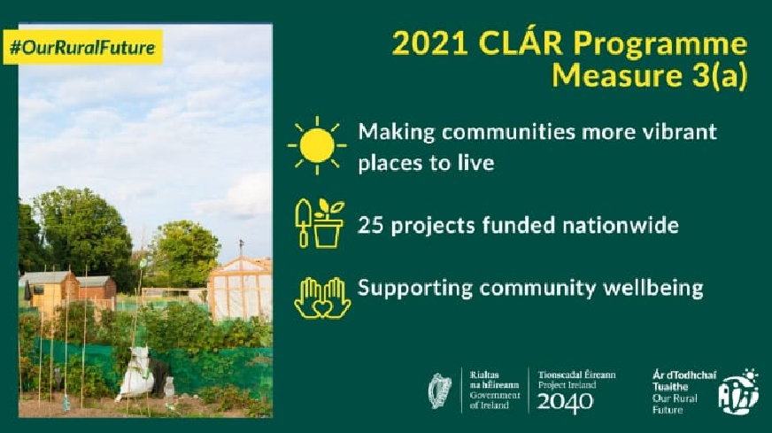The funding will support local groups in developing community and sensory gardens, outdoor spaces and allotments. In practical terms, communities will receive funding for the likes of raised flower beds, wildflower gardens, sensory planting, polytunnels, outdoor equipment, picnic tables and shelters. All projects must adhere to the Leave No Trace principles.

The 2021 CLÁR Programme is a key part of the Government’s five-year rural development strategy, Our Rural Future. This year alone, the scheme has delivered over €5.7 million for projects across the country.

Announcing the funding, Minister Humphreys said:

“The projects receiving funding today will help to channel the real sense of pride that people in rural Ireland have in their localities and their environment. Funding for such community-led projects is at the very core of the Government’s vision for rural Ireland as set out in ‘Our Rural Future’. The funding will go a long way in terms of assisting our Community Groups, TidyTowns and Development Associations in making their localities more vibrant places to live and raise a family. This funding will lead to the creation of community spaces where people can come together and meet their families and friends.”

Examples of some of the successful organisations include:

* Bruckless Community Park, Co Donegal: Sensory space and associated planting, seating and BBQ area - €50,000
* Ballinamore Community Garden, Co Leitrim: Installation of a large polytunnel and a teaching tunnel - €8,438
* Abbeylara Community Garden, Co Longford: Sensory Garden, Outdoor stage, Children’s Play Area and Picnic benches - €50,000
* Ballybay Allotments and Community Garden, Co Monaghan : development of allotments and community garden - € 35,586
* Cappoquin Community Garden/Waterford Area Partnership, Co Waterford: New community garden - €5,085
* Tournafulla Sustainable Living Community, Co Limerick: Transform an area of waste land into a vibrant community garden - €50,000

The full list of successful projects is available at the following link: <https://www.gov.ie/en/collection/bd890-clar-2021-funding-approvals/>

This announcement is in addition to funding of over €4.2 million for 104 projects which the Minister announced on 30 August 2021 under Measures 1 and 2 of CLÁR and over €747k for 14 projects under Measure 3(b) announced on 2 September 2021.

An announcement regarding the CLÁR Innovation Measure will be made in the coming weeks.

**Photography Competition**

Last year you will recall we held a photography competition. We were delighted with the response it received with hundreds of beautiful images submitted from all part of the country. There are so many stunning places out there and so many of you are so talented when it comes to capturing those places in photo and indeed in poetry as we have seen so many times in the Newsletter.

We are now calling on all our photography enthusiasts to get out there and capture your flowers while they are still in bloom, perhaps the autumn sun rise or indeed sun set, in the weeks ahead, nature really can be really generous to us with photo opportunities.

This year again we will have a special category for our junior entrants up to 18 years of age, this category will attract a first prize of €150 and a second prize of €75. The main competition will have a first Prize of €250, second prize of €150 and a third prize of €75. Total prize money of €700.

* Photographs should be emailed to [tidytowns@drcd.gov.ie](mailto:tidytowns@drcd.gov.ie) stating which TidyTowns group you are from or if you are entering the junior element.
* Photographs should not contain close up images of other people unless you have received their permission to take and submit the photograph to this competition.
* The TidyTowns Unit will judge all entries and prizes will be awarded as above.
* The TidyTowns Unit may use photographs submitted for social media or publications going forward.
* The closing date for entries is Friday October 29th.
* Results will be announced on Social Media and in the December Newsletter.

**Reeling in the Years - TidyTowns**

The SuperValu TidyTowns competition has been in place since 1958. In that time well over 2,000 different towns and villages have entered. We currently have in the region of 1,000 active TidyTowns groups in place around the county.

Some of the groups have been with the competition from the very start and have entered every single year while others are brand new in for 2021. Whatever you’re TidyTowns history is, you are welcome to the competition and we are delighted to have you along for the journey.

No doubt some of you have some memorabilia from the early years or maybe even more recently, if so we would love to hear from you. We are looking at doing a feature in the newsletter later in the year on the way the competition has evolved over the years. Perhaps you have an old invite to an awards ceremony or a regional awards ceremony, an old adjudication report, an old certificate or an old entry form. All of these items will show us how the competition was delivered in times gone by and might make for interesting reading for some of our readers.

Please do not sent original items to us, if you have material, perhaps you could take a photograph of it and send it in to us. Keep a watch out later in the year to see if your material is featured. Perhaps you have a story of a trip to an awards ceremony or an award your group were presented with, we would love to hear from you.

**SuperValu Gift Card Winners**

**SuperValu**, who have been our loyal sponsors for 30 years have again this month given us four **SuperValu** Gift Cards to present to groups, whose stories have featured in recent issues of the Newsletter. One of the managers in the Department read through the recent issues and has selected the following worthy winners. Many thanks Edel for your support on the selection of our winners.

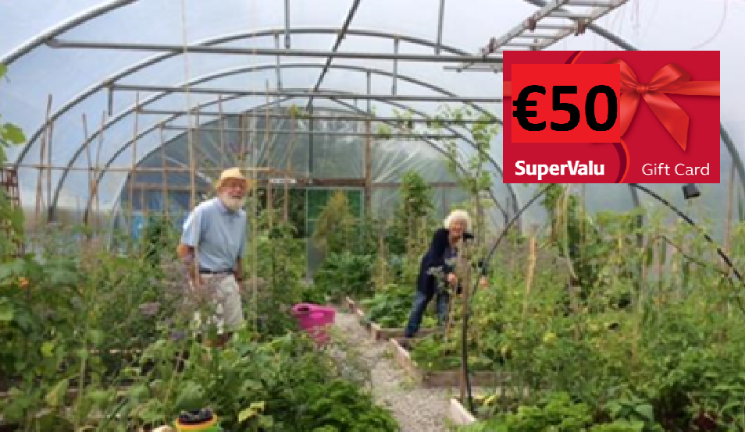In the June Issue we brought you a story from **Seem TidyTowns** about their Community Polytunnel and Allotments located in the Garden of the Senses in the heart of our village. We read about great upcycling of old waste timer and a timber bed frame which now serve as a bench. For your sustainable effort and your Community Garden endeavours, we are delighted to award you a €50 **SuperValu** Gift Card.

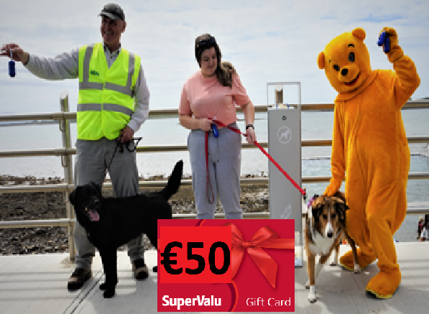In the July Issue **Belmullet TidyTowns** told us about a campaign aimed at tackling the persistent problem of dog fouling around the town. The campaign was kicked off with a visit from a special guest called Winnie – the only ‘Pooh’ who is welcome on the streets of Belmullet! The town are to be commended for their awareness raising campaign and facilities put in place to help dog owners be more responsible. We are delighted to award you a €50 **SuperValu** Gift Card.

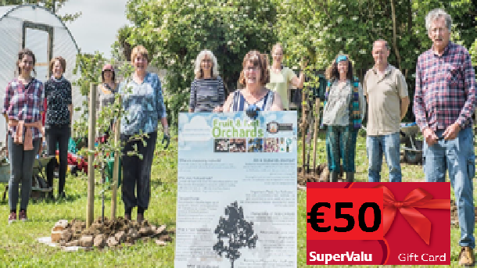In the July issue, we also brought you a piece from **Ballyduff Tidy Towns** who have planted a community orchard together with Transition Kerry course facilitators and other Community Biodiversity Leadership course participants. The apple trees will attract pollinators and provide habitats for local wildlife, as well as providing organic locally produced apples. For your efforts a €50 **SuperValu** Gift Card is on its way to your group. Well done.

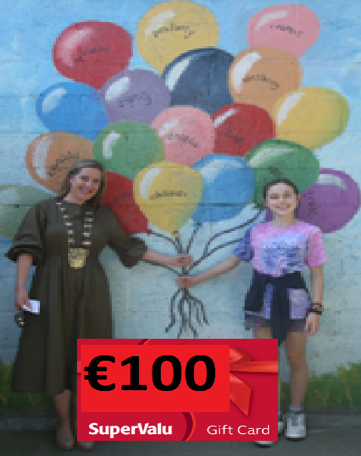In the August Newsletter **Rush TidyTowns** committee shared the Ros-Eó Mural Wall, which involved the hard work of over 100 volunteers from Rush community coming together and bringing this wonderful project to life. The 18 murals were painted by 31 local artists on a dilapidated 450 foot long, 10 foot high wall with 51 separate panels. The murals are themed to represent aspects of Rush during the past, present and future.

Despite Covid, the community found a way to uplift people’s spirits, whether it be involved as an artist, or just viewing the Mural Gallery on their daily walks. Well done to all involved and for your efforts you are being awarded this month’s top prize of a €100 **SuperValu** Gift Card.

Well done to all our winners and thanks again Edel for selecting these for us. Keep your stories and poems coming in and remember that photography competition.

**Skibbereen TidyTowns Survey**

Sandra Flynn, a PhD researcher and volunteer with Skibbereen TidyTowns got in touch with us to tell us that she is conducting a study on digital skills and lifelong learning amongst older adults in Ireland and is looking for participants.

The study aims to explore the experiences of older adults and lifelong learning, with specific focus on intergenerational exchanges and digital skills. Little is known about the concept of intergenerational learning in Ireland outside of formal learning environments. By taking part in this study your insights will help contribute to our understanding of the contribution intergenerational learning can make to lifelong learning and digital skills development of older adults. Participants aged 55 years and over are invited to one of two parts as appropriate.

Part a) involves an anonymous online survey for those who access the Internet through any digital device. The survey takes no longer than 15 minutes to complete and may be accessed through this link: <https://wp.me/p8OE8C-g8> Participants wishing to continue to an optional 45-minute interview with Sandra to share their experiences further, may enter their contact details at the end of the survey.

Part b) applies to those who do not access the Internet and would be interested in sharing their experiences with Sandra in a telephone interview. If you know anyone who you think may be interested please pass this information along to them and ask to contact Sandra directly at 086-847 2348 to arrange an interview.

If you have any questions about the study please contact Sandra by email at s.flynn2@lancaster.ac.uk

Twitter: <https://twitter.com/skibbtidytowns>

Facebook: <https://www.facebook.com/SkibbereenTidyTowns/>

Blog: <https://skibbtidytowns.wordpress.com>

**Streetscape Enhancement Funding**

****Minister for Rural & Community Development Heather Humphreys T.D. announces the 124 towns and villages to benefit from new €7 Million fund to enhance streetscapes & shopfronts

Projects to include upgrades to building facades, artwork, murals, lighting, street furniture and canopies. The investment is designed to make rural towns and villages more colourful, vibrant and attractive places. Minister Humphreys encourages businesses and property owners to contact their local authority to apply

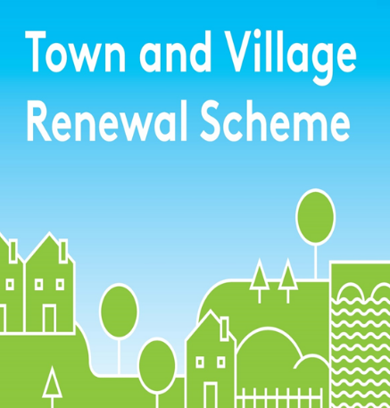The Streetscape Enhancement Initiative is a key part of Our Rural Future and is designed to make our rural towns and villages more attractive places to live, work and visit. Under the scheme, property owners will be provided with funding to improve the facades of their buildings, carry out artwork and install features such as canopies and street furniture. The 124 towns and villages announced by the Minister today were selected by each local authority, which will now begin the process of advertising locally for applications.

The types of projects to be supported include:

• Strategic collaboration between property owners to paint buildings or shopfronts in vibrant colours

• Commissioning of murals in towns and villages

• Upgrade or restoration of historic / traditional shopfronts

• Provision of street planting, shrubbery, trees and flowers boxes

• Illumination and lighting of architectural features

• Installation of canopies and street furniture

• Decluttering of streetscapes with removal of unnecessary signs / wires

Announcing the 124 towns and villages, Minister Humphreys said:

“This unique initiative is about making our rural towns and villages more attractive and welcoming places for locals and visitors alike. Whether it’s painting buildings in vibrant colours, upgrading shop fronts or installing canopies or street furniture – this fund will provide a welcome boost to rural communities the length and breadth of the country."

**STQRY**

We have been contacted by Declan Breathnach to share some information with you on their company STQRY.

STQRY is a software company changing the visitor attraction industry around the globe by providing world class digital solutions for destinations with stories to share.

Harness the power of technology to allow visitors to engage deeper, explore further, and discover more.

Visitors love engaging with interactive experiences, especially when they can easily use their own device to dig deeper. STQRY makes creating those experiences easier. From a simple app based audio guide to a county wide app encompassing various towns and cities, no story is too big or too small for the STQRY platforms.

Choose from a range of amazing features to create location-based tours, virtual tours, mobile, and web apps, audio guides, games, and online collections.  
Since STQRY's inception in 2006, they have helped thousands of destinations around the world ranging from museums, parks, cities, and historic sites of all sizes to connect with their visitors.

For further details on producing quality branded self-guided digital trails/tours feel free to contact Declan Breathnach at 0872697638 or [dbreathnach@stqry.com](mailto:dbreathnach@stqry.com)  
Please visit the website for more information <https://stqry.com/>

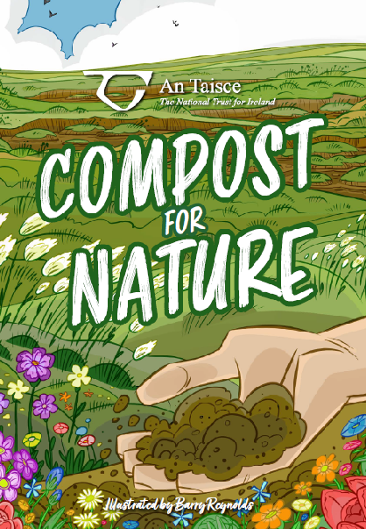

**An Taisce - Compost for Nature guide**

An Taisce would like to share with you all their new “Compost for Nature Guide”. This guidance provides alternative options and practices to using milled peat as a growing medium for gardening and horticulture.

It became a particularly hot topic over the last year with the cessation of peat extraction by Bord na Mona, the importation of garden peat from Germany and elsewhere to fill the gap, and the increased amount of gardening because of lockdown.

The guide can be viewed on the following website; <https://www.antaisce.org/compost>

There is also a video of a webinar on composting that you can watch information on all aspects of composting.



**Cloontuskert TidyTowns - Co. Roscommon**

**Community Orchard**

The Orchard symbolises our vision to bring our former Bord na Móna village into the era of sustainability as a small community currently at the center of massive national and global climate change policy.

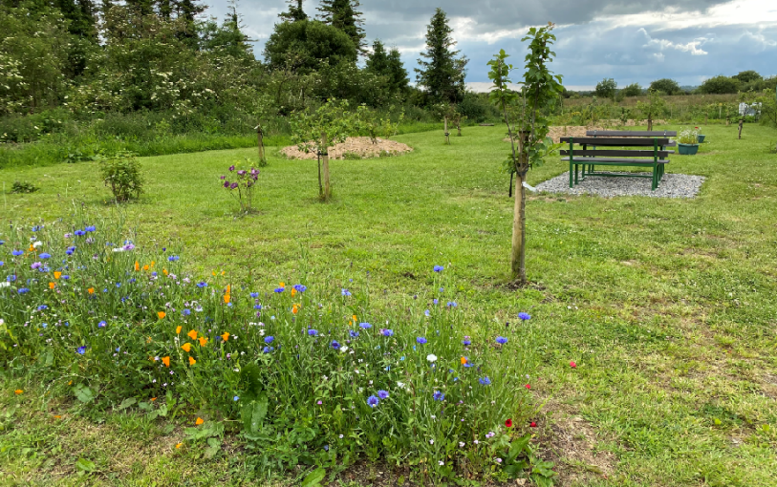

Cloontuskert is a jewel in the crown of rural Roscommon. Lying at the foot of the Sliabh Bawn mountain, the village holds an exciting past. The village is situated in East Roscommon, close to the county Longford border. In 1952 the village was built as one of the original Bord na Móna housing schemes, the only one of its kind developed in Roscommon, which catered for the families of workers who came from all over Ireland to gain employment on the bogs and to begin a new life in Cloontuskert. Seven of these villages were developed by Bord na Móna nationwide during the early 1950s.

Cloontuskert Community Orchard is our most recent flagship project. Our Orchard is situated on a site to the rear of our village that was traditionally used for dumping of all types of wastes (building materials, old electrical waste, everyday household waste), dating back to the 1950s up until recent times. With minimal funding and resources, over the course of a five-year period, and despite the impact of the lockdowns we faced during the Covid-19 pandemic, the community has shown huge resilience in cleaning up this former waste ground and transforming it into a much-loved community facility where we aim for biodiversity to thrive, and for residents to have their own source of fruit, berries, and vegetables through the creation of allotments on site from upcycled wooden pallets.

We utilised Galway Roscommon Education Training Board community education courses with local tutor Hannah Mole, of Earthcare Permaculture Design, to inform our methodology for completing the project, with groundwork expertise kindly provided by the wonderful local Ballyleague Mens Shed, within which Chairman Joe Cribbin leads the way. Teaching and learning centered around the ground preparation and planting works needed to complete the project by exploring the relevant theory and its application to our project along the way. Ever resilient, the Cloontuskert community completed this year’s spring course by Zoom due to the Covid-19 lockdown which steered the final planting stages of the project.

In early 2021 a total of 18 different trees were planted on site of various sizes to suit the peaty soil on site. The trees included apple, plum, damson and a very interesting choice recommended by our tutor Hannah Mole in the medlar tree. The soft fruit plantings included blueberry, raspberry, gooseberry, and balloon berry.

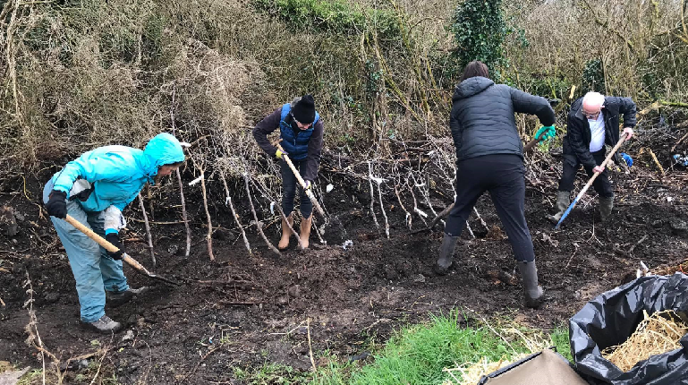Three Hügelkultur mounds were constructed from raw materials available on site based on Hannah’s permaculture-based design of our Orchard. To assist biodiversity as much as possible we also sowed a permaculture mix hedge to the rear of the site in 2020 to act as a natural windbreak for our Orchard. Our much-loved native wildflower strip was sown on site in early 2021 using native annual wildflower seed supplied from Blooming Native Wildflowers.

There are also two sections of raised planter beds on the site. The rearmost bedding was constructed to accommodate some autumn planting as part of our GRETB community education courses. Along this area, as part of National Tree Week 2021 we planted some bare root Hazel native saplings supplied through the Environment section of Roscommon County Council. The other area of raised planter beds was constructed by our amazing Junior TidyTowns members and their parents/siblings who constructed some upcycled planters from old wooden pallets. These pallets were collected from local tradesman for community upcycling project use. Cloontuskert Junior TidyTowns members have also been involved with the incredible Green Schools efforts made by Cloontuskert N.S. We are delighted to have their help in furthering green activities here in the village itself, which are evident in making our Community Orchard what it is today.

Cloontuskert has become synonymous in the local area in recent years as we have been planting sunflowers at various locations in the village, most prominently at Cloontuskert Heritage Sculpture Garden where have a dedicated space for pollinator-friendly planting and other physical features to enhance biodiversity, such as the drilling of nesting holes in tree stumps as nesting site for solitary bees. This year we trialed the growing of large sunflowers along the entrance-side boundary to give an additionally attractive look to the Community Orchard. We have worked closely with Ballyleague Mens Shed on this project as they kindly grow the sunflowers from seed and supply them to us subsequently, as is the case with much other planting in the village.

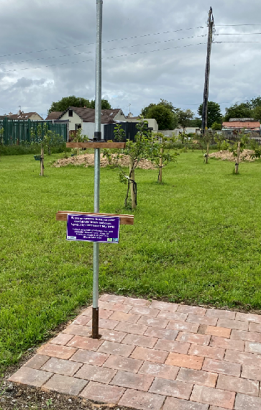

There is also a Community Art Easel on site which was installed in previous months. Its aim is to provide a safe means of outdoor recreation which brings benefits to mental health through the enjoyment and appreciation of this tranquil space, whilst amongst nature. Those who visit the site comment at the tranquility of the birdsong that can be heard on site.

We were honoured to have recently been selected by GRETB to represent Roscommon in the filming of four communities (ourselves from Roscommon and three others in Galway) who took part in their community education courses.

The film crew visited our Community Orchard in late June 2021 and the film is currently being put together. Two youth members of our committee took part in the filming as part of being interviewed on the transformation that has taken place at the Community Orchard site. We were also delighted to have recently featured in a Sunday Times piece on community gardens that have arisen from previous waste grounds, the history that lies behind our Orchard.

We would like to express our sincere gratitude to everyone who assisted us in the completion of this project and to those who provided grant funding, with particular thanks to GRETB and Roscommon County Council.

Well done to all involved in this transformative project in Cloontuskert, it really demonstrates where there is a vision and support from the community, great things can be achieved.

 <https://www.facebook.com/OfficialSuperValuTidyTowns>



[Description: Description: Description: https://encrypted-tbn2.gstatic.com/images?q=tbn:ANd9GcTn6e_yvEEKZGqngkOvFQKXiE5grEl9MBv8f3BIJGAnDVia4IA6BMWDw64](https://www.google.ie/url?q=https://about.twitter.com/press/brand-assets&sa=U&ei=gIVOU7azCeed7Qafq4DoCw&ved=0CC4Q9QEwAQ&sig2=_2Ys344bv7jS9rXT1Izm4w&usg=AFQjCNEMyI7-tFvyJYa1KkCdXm5XILcS9g)   <https://twitter.com/TidyTownsIre>

<https://www.tidytowns.ie>

Remember to share the Newsletter with your wider TidyTowns group and volunteers through your own social media or through email. It’s good to keep everyone in the Picture!!!

**Keep in Touch**

Thank you for taking the time to read our September issue, as always we would encourage you to share the newsletter with your wider community and remember to share your projects, poetry and photographs with us. This is your newsletter. Congratulations to our winners this month and thank you as always to all our contributors. Thanks also to **SuperValu** for their ongoing support and sponsorship. Remember the photography competition and our call for TidyTowns memorabilia. All issues of the Newsletter are on the TidyTowns website at <https://www.tidytowns.ie/about-us/newsletters/>.

Best Wishes as always from Anne, Helen & John in The TidyTowns Unit

Department of Rural and Community Development

Government Buildings

Ballina

Co Mayo

F26 E8N6

Email: [tidytowns@drcd.gov.ie](mailto:tidytowns@drcd.gov.ie)

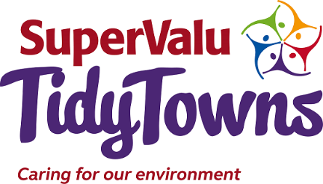Tel: **01 – 773 6938 or 01 – 773 6912** from September 24th